

Metreos ActiveRelay

Administrator Guide
Metreos Communications Environment 2.1.4

Information in this document is subject to change without notice.

Copyright © 2005 Metreos Corporation. All rights reserved. Metreos trademarks marked with ® or © herein are registered or protected trademarks of Metreos in the U.S. and foreign countries. All other trademarks in the document are the property of their respective owners.
Licensing Terms
Use of this Software is subject to license restrictions. Carefully read this license agreement before using the software.
This End User License Agreement (the “Agreement”) is a legal agreement between you, either individually or as an authorized representative of the company or organization acquiring the license, and Metreos Corporation (“Metreos”). USE OF SOFTWARE INDICATES YOUR COMPLETE AND UNCONDITIONAL ACCEPTANCE OF THE TERMS AND CONDITIONS SET FORTH IN THIS AGREEMENT. If you do not agree to these terms and conditions, promptly return or, if electronically received, certify destruction of the Software and all accompanying items within five days after receipt of Software and you will receive a full refund of the applicable license fees paid.
1. License Grant
a. The software programs you are installing, downloading, or have acquired with this Agreement, including any related equipment or hardware, documentation, updates, upgrades, modifications, revisions, copies and design data (“Software”) are copyrighted, trade secret and confidential information of Metreos and its licensors who maintain exclusive title to all Software and retain all rights not expressly granted by this Agreement. Metreos grants to you, subject to payment of appropriate license fees, a non-exclusive, non-transferable, internal-use only, term license to use the Software owned or distributed by Metreos in machine readable, object-code form on the computer hardware or at the site(s) for which an applicable license fee has been paid, as authorized by Metreos.
b. To the extent that you design applications that operate on the Metreos Communications Environment (the “MCE”), Metreos grants you a non-exclusive, non-transferable, internal-use only, term license to use the Software, including the MCE, for the purposes of operating such programs, subject to payment of appropriate license fees.
c. The license granted herein is contingent on your (or your organization’s) continued acceptance and subscription to the maintenance and support terms provided by Metreos. Termination by you or your organization of ongoing maintenance and support requirements terminates the license granted herein.
2. Restrictions and Intellectual Property Ownership
a. You may not (i) remove or modify any notice of Metreos’ proprietary rights, (ii) re-license, rent, lease, timeshare, or act as a service bureau or provide subscription services for the Software, (iii) use the Software to provide third-party training, except for training agents and contractors authorized under this Agreement; (iv) assign this Agreement or give the Software or an interest in the Software to another individual or entity; (v) cause or permit reverse engineering or decompilation of the Software; (vi) disclose results of any Software benchwork tests without Metreos’ prior written consent; or (vii) modify the Software or any portions thereof without Metreos’ prior written consent.
b. The Software, which is copyrighted, and any modifications, upgrades, or updates thereto, is the sole and exclusive property of Metreos and is a valuable asset and trade secret of Metreos. Metreos retains all ownership and intellectual property rights to the Software and to any modifications, upgrades, or updates thereto. Except for the rights granted in herein above, you shall have no right, title, or interest of any kind in or to the Software.
c. Metreos may audit your use of the Software. If Metreos gives you or your organization reasonable advance written notice, you agree to cooperate with the audit, and to provide reasonable assistance and access to information. You agree to immediately remit any underpaid license and technical support fees determined as the result of such audit.
3. Term and Termination.
a. This Agreement remains effective until expiration or termination. This Agreement will immediately terminate upon notice if you exceed the scope of the license granted or otherwise fail to comply with the provisions in sections 1 and 2 above. For any other material breach of the Agreement, Metreos may terminate this Agreement if you are in breach and fail to cure the breach within thirty (30) days of written notification. If Software is provided for a limited term use, this Agreement will automatically expire at the end of the authorized term.
b. Upon termination of this Agreement for any reason, you shall within ten (10) business days return to Metreos all Software Additionally, you agree to delete from any permanent machine storage (i.e., hard disk) previously loaded copies of the Software in all forms. Upon request of Metreos, you shall certify in writing that all copies of the Software and associated documentation have been destroyed or returned to Metreos. The indemnity and limitation of liability obligations hereunder, as well as your obligations with respect to confidential treatment of the Software and Metreos’ trade secrets, other intellectual property, and proprietary information, shall survive the termination of this Agreement.
4. Limited Warranty.
a. Metreos warrants that the Software will substantially operate as described in the applicable Software documentation for ninety (90) days after Metreos delivers it to you. THE WARRANTY HEREIN IS EXCLUSIVE AND IN LIEU OF ALL OTHER WARRANTIES, WHETHER EXPRESS OR IMPLIED, INCLUDING THE IMPLIED WARRANTIES OF MERCHANTABILITY AND FITNESS FOR A PARTICULAR PURPOSE. METREOS MAKES NO WARRANTY THAT ANY SOFTWARE WILL PERFORM ERROR-FREE OR UNINTERRUPTED, OR THAT ALL ERRORS THEREIN CAN OR WILL BE CORRECTED. METREOS FURTHER DISCLAIMS ANY IMPLIED WARRANTIES ARISING FROM COURSE OF PERFORMANCE, COURSE OF DEALING OR USAGE OF TRADE.
b. For any breach of the above warranty, Metreos’ entire liability and your exclusive remedy shall be, at Metreos’ option, either (1) refund of the fees paid upon return of the Software to Metreos, or (2) correction or replacement of the Software that does not meet this limited warranty, provided you have complied with the terms of this Agreement.
5. Indemnity
a. Metreos will defend and indemnify you against a claim that any Software, infringes a patent or copyright, provided that: (i) you notify Metreos in writing within thirty (30) days of the claim; (ii) Metreos has sole control of the defense and all related settlement negotiations; and (iii) you provide Metreos with the assistance, information, and authority reasonably necessary to perform the above; reasonable out-of-pocket expenses incurred by you in providing such assistance will be reimbursed by Metreos.
b. Metreos shall have no liability for any claim of infringement resulting from: (i) your use of a superseded or altered release of the Software if infringement would have been avoided by the use of a subsequent unaltered release of the Software which Metreos provides to you; or (ii) any information, design, specification, instruction, software, data, or material not furnished by Metreos or (iii) any combination of the Software with other hardware, software or processes that, but for the combination, the Software would not be infringing.
c. In the event that some or all of the Software is held or is believed by Metreos to infringe, Metreos shall have the option, at its expense: (i) to modify the Software to be non-infringing; or (ii) to obtain for you a license to continue using the Software. If it is not commercially feasible to perform either of the above options, then Metreos may require from you return of the infringing Software and all rights thereto. Upon return of the infringing Software to Metreos, you may terminate the Agreement with ten (10) days’ written notice and you shall be entitled to a pro-rata refund of the fees paid for the infringing Software. This subsection sets forth Metreos’ entire liability and exclusive remedy for infringement.
d. You will defend and indemnify Metreos and its licensors against any claim incurred by, borne by or asserted against Metreos or its licensors that relates to or results from (i) your use of the Software, (ii) any intentional or willful conduct or negligence by you or (iii) any breach of an applicable representation, covenant or warranty contained herein.
e. Should the party seeking indemnification (“Indemnitee”) reasonably determine that the party from whom indemnity is sought (“Indemnitor”) has failed to assume the defense of any claim referenced herein, Indemnitee shall have the right to assume such defense and have all expense and cost of the defense reimbursed by Indemnitor, including reasonable attorneys fees.
6. Confidentiality
The Software contains proprietary and confidential information of Metreos as well as trade secrets owned by Metreos. You agree to hold the Software in strict confidence and not to disclose the Software in any way except as expressly permitted hereunder. You agree to protect the Software at least to the same extent that you protect your similar confidential information, but in no event less than reasonable care. You further agree that you will not, directly or indirectly, copy the structure, sequence, or organization of the Software, nor will you copy any portion of the Software or related documentation to produce software programs that are substantially similar to the Software.
7. LIMITATION OF LIABILITY
EXCEPT WHERE THIS EXCLUSION OR RESTRICTION OF LIABILITY WOULD BE VOID OR INEFFECTIVE UNDER APPLICABLE LAW, IN NO EVENT WILL METREOS BE LIABLE FOR ANY INDIRECT, INCIDENTAL, SPECIAL, OR CONSEQUENTIAL DAMAGES, OR DAMAGES FOR LOSS OF PROFITS, REVENUE, DATA, OR USE, INCURRED BY YOU OR ANY THIRD PARTY, WHETHER IN AN ACTION IN CONTRACT OR TORT, EVEN IF METREOS OR ANY OTHER PERSON HAS BEEN ADVISED OF THE POSSIBILITY OF SUCH DAMAGESMETREOS’ LIABILITY FOR DAMAGES HEREUNDER SHALL IN NO EVENT EXCEED THE AMOUNT OF FEES PAID BY YOU FOR THE SOFTWARE OR SERVICE GIVING RISE TO THE CLAIM. IN THE CASE WHERE NO AMOUNT WAS PAID, METREOS SHALL HAVE NO LIABILITY FOR ANY DAMAGES WHATSOEVER.
8. Assignment; Jurisdiction.
This Agreement will be binding upon, and will inure to the benefit of, the permitted successors and assigns of each party hereto. You may not assign, delegate, transfer, or otherwise convey this Agreement, or any of its rights hereunder, to any entity without the prior written consent of Metreos, and any attempted assignment or delegation without such consent shall be void. This Agreement, and all matters arising out of or relating to this Agreement, shall be governed by the laws of the State of Texas, United States of America. Any legal action or proceeding relating to this Agreement shall be instituted in any state or federal court in Travis or Dallas County, Texas, United States of America. Metreos and you agree to submit to the jurisdiction of, and agree that venue is proper in, the aforesaid courts in any such legal action or proceeding.
9. Severability; Waiver
In the event any provision of this Agreement is held to be invalid or unenforceable, the remaining provisions of this Agreement will remain in full force. The waiver by either party of any default or breach of this Agreement shall not constitute a waiver of any other or subsequent default or breach. Except for actions for nonpayment or breach of either party’s intellectual property rights, no action, regardless of form, arising out of this Agreement may be brought by either party more than two years after the cause of action has accrued. The headings appearing in this Agreement are inserted for convenience only, and will not be used to define, limit or enlarge the scope of this Agreement or any of the obligations herein.
10. Restricted Rights Notice.
The Software is commercial in nature and developed solely at private expense. The Software is delivered as "Commercial Computer Software" as defined in DFARS 252.227-7014 (June 1995) or as a commercial item as defined in FAR 2.101(a) and as provided with only such rights as are provided in this Agreement, which is Metreos’ standard commercial license for the Software. Technical data is provided with limited rights only as provided in DFAR 252.227-7015 (Nov. 1995) or FAR 52.227-14 (June 1987), whichever is applicable.

TABLE OF CONTENTS

1. Overview 1

2. Step 1. Configure the Metreos Communications Environment 1

2.1. Adding a media server 1

2.2. Adding an H.323 telephony server 2

2.3. Adding a CallManager telephony server 4

3. Step 2. Configure Cisco CallManager for the MCE 6

3.1. Adding an H.323 gateway for the MCE 7

3.2. Adding ActiveRelay to the IP phone service 9

4. Step 3. Install the ActiveRelay Application 11

5. Step 4. Configure the ActiveRelay Application 12

6. Step 5. Edit the Default Partition 15

7. Step 6. Edit the Trigger Parameter of the ActiveRelay Partition 16

8. Step 7. Set Up ActiveRelay Users 17

9. Step 8: Create a Shared Line Configuration 18

10. Step 9: Set Up Other Partitions 19

11. Appendix A: Troubleshooting Symptoms A1

11.1. R001 CallManager is not configured to route calls to the Metreos ActiveRelay route list A2

11.2. R002 All MCE servers are no longer in service A2

11.3. R003 There are no available voice channels on the PSTN gateway A3

11.4. R004 The firewall is blocking H.323 connections on port 1720 A3

11.5. R005 The IP addresses of the MCE gateways are not configured correctly in the CallManager A4

11.6. R006 The MCE that took the call encountered an error initiating ActiveRelay A4

11.7. R007 CallManager is not configured to route the number entered as a Find Me number A4

11.8. R008 The configured Call Route Group of the relevant Active Relay partition is not configured correctly A5

11.9. R009 There are no available RTP media server connections A5

11.10. R010 There are no available enhanced RTP media server connections A6

11.11. R011 No media servers are configured on the MCE currently processing the call A6

11.12. R012 The firewall is blocking the H.245 port range for TCP connections from the MCE to CallManager A7

11.13. R013 The firewall is blocking the H.245 port range for TCP connections from CallManager to the MCE A7

11.14. R014 One or more of the MCE servers are no longer in service A8

11.15. R015 Voice Mail Box on the user account is not configured correctly A8

- Overview
You will complete the following tasks to set up ActiveRelay in the Metreos Communications Environment (MCE).
- Configure the Metreos Communications Environment.
- Configure the Cisco CallManager for the Metreos Communications Environment.
- Install the ActiveRelay application.
- Configure the ActiveRelay application.
- Edit the default partition.
- Set up ActiveRelay users.
- Edit the trigger parameter of the ActiveRelay partition
- Create a Shared Line Configuration
- Set up other partitions.
- Step 1. Configure the Metreos Communications Environment
You will use the Metreos Communications Environment console (mceadmin) to configure the Metreos Communications Environment. The steps involved are:
- Adding a media server.
- Adding an H.323 telephony server.
- Adding a CallManager telephony server.
  - Adding a media server
Complete the following steps to add a media server to the MCE configuration.
Procedure
- Go to http://<servername or IPaddress>/mceadmin.
- Select Media Servers.
- Click the Add a Media Server button. The following screen appears.
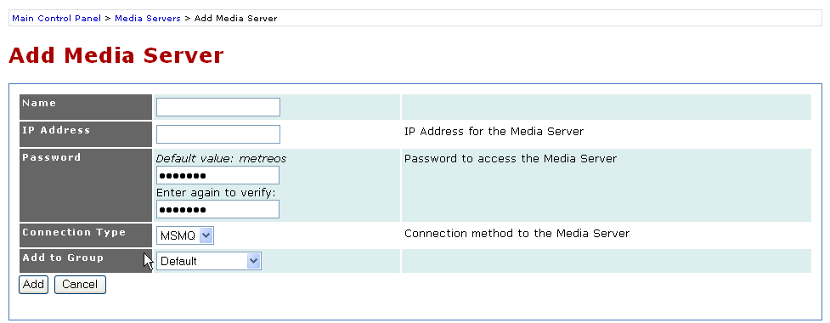
- Enter a descriptive name for the media server in the Name field, and the media server’s IP address in the IP Address field.
Figure 1. Adding a Media Server in the Metreos Management Console
- Enter the SFTP password for the media server in the Password field, and then enter the same password again in the field below to confirm the password you originally entered.
- Select a connection method to the media server in the Connection Type field.
- As an option, select a group from the Add to Group pulldown menu, or leave the field set as Default to place the media server into the default media group.
- Click the Add button to complete configuring the MCE.
- Repeat steps 2 through 5 to add additional media servers as needed.
  - Adding an H.323 telephony server
Complete the following steps to add H.323 telephony servers.
Procedure
- Go to http://<servername or IPaddress>/mceadmin.
- Select Telephony Servers. The following screen appears.
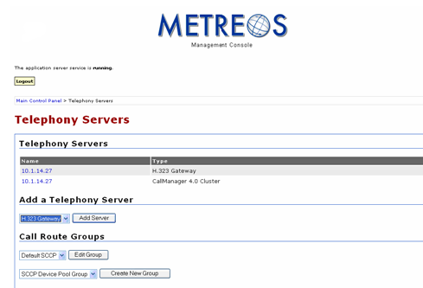
- Under Add a Telephony Server, select H.323 Gateway from the pull-down menu. Click the Add Server button and enter the H.323 gateway name, a description, and the IP address of the H.323 gateway server. See Figure 3 for an example. Note that the IP address entered should correspond to a CallManager node that is processing calls.
Figure 2. Adding a Telephony Server in the Metreos Management Console
The name displayed in the Create New Group field is the name of the Call Route Group to which this H.323 gateway is being added.
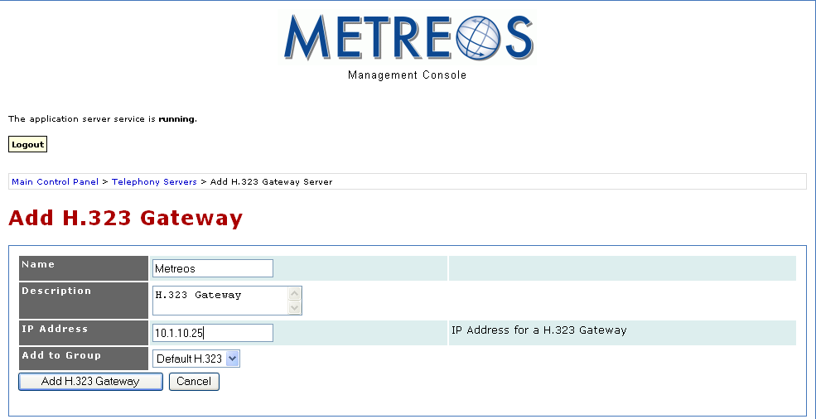
  - Adding a CallManager telephony server
Figure 3. Adding an H.323 Telephony Server in the Metreos Management Console
Complete the following steps to add a CallManager telephony server.
Procedure
- Go to http://<servername or IPaddress>/mceadmin.
- Select Telephony Servers.
- Under Add a Telephony Server, make sure that Call Manager is selected in the pull-down menu as shown in the following figure.
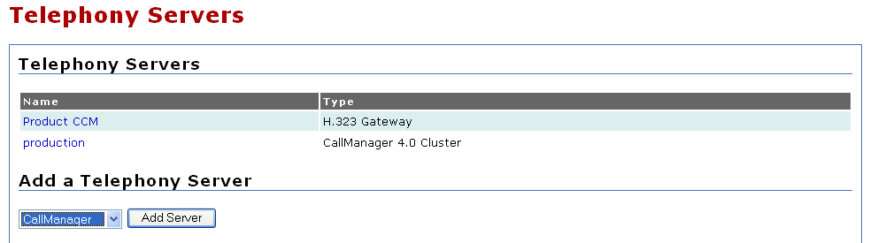
- Click the Add Server button. The following screen appears.
Figure 4. Call Manager Selected under Add a Telephony Server
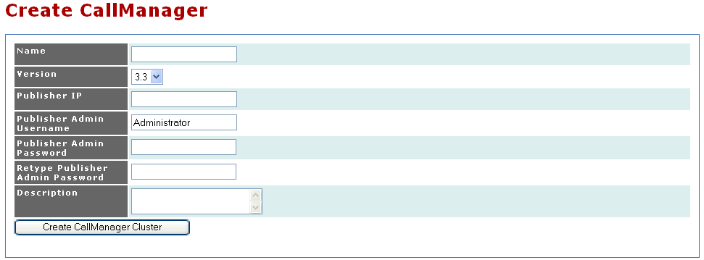
- Enter the CallManager name, publisher IP address, publisher IP username, publisher admin password (twice), and a short description.
Figure 5. Adding a CallManager Telephony Server in the Metreos Management Console
- Click the Create CallManager Cluster button. The following screen appears.
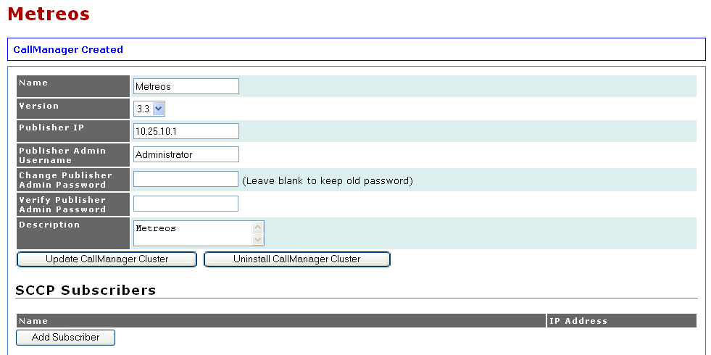
- Under SCCP Subscribers, click the Add Subscriber button as shown in the following figure.
Figure 6. CallManager Selected under Add a Telephony Server
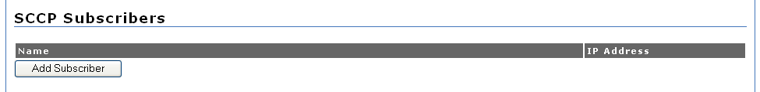
- Enter the name and IP address of the subscriber. This should be a CallManager node that is processing calls.
Figure 7. Adding Subscribers to CallManager Nodes
- Click the Add Subscriber button as shown in the following figure.
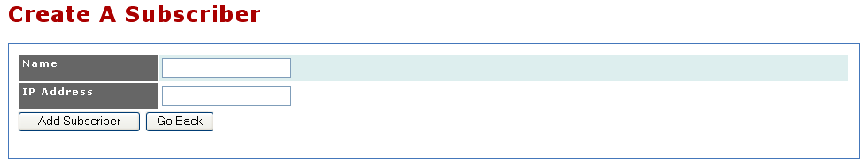
- After you enter each subscriber, click the Update CallManager Cluster button.
Figure 8. CallManager Subscribers Nodes
- After you have created a SCCP subscriber, you can create an SCCP device pool. Select the Create SCCP Device Pool button in the configuration page of the CallManager Cluster you just created.
- On the Create A Device Pool page, enter the name of the pool, the number of SCCP devices to register, the starting six hexadecimal characters to use for the device pool, the primary subscriber, the secondary subscriber, and choose which SCCP call route group to which to add the devices.
The number of devices in this pool will determine the number of users that can be enabled for ActiveRelay. The MCE will register the phones to the primary subscriber you defined in the SCCP device pool immediately upon creation.
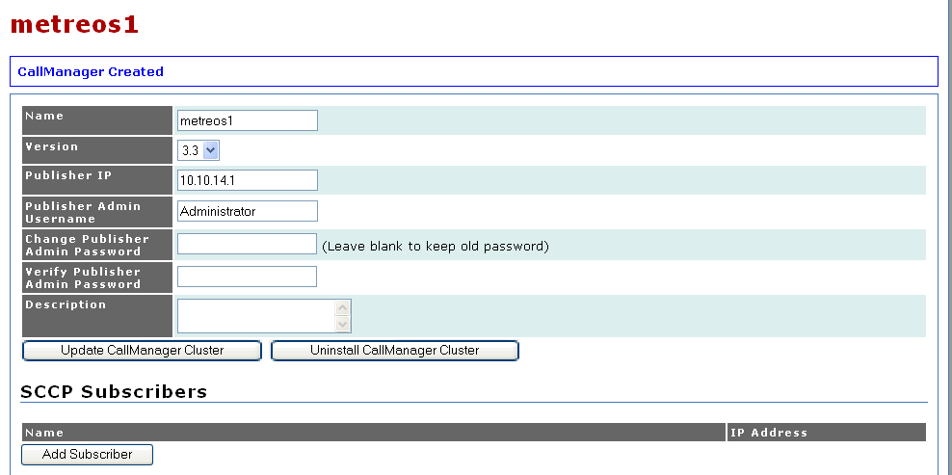
- Step 2. Configure Cisco CallManager for the MCE
Figure 9. Call Manager Created
To configure the Cisco CallManager for the MCE, you must do the following:
- Adding an H.323 gateway for the MCE
- Adding ActiveRelay to the Cisco IP phone service
These tasks are described in the following subsections.
  - Adding an H.323 gateway for the MCE
Complete the following steps to add an H.323 gateway that represents the Metreos Communications Environment.
You will create one H.323 gateway for each MCE server.
Procedure
- Go to https://<servername or IP address>/ccmadmin.
- Select Device→Add a New Device from the top menu bar as shown on the following screen.
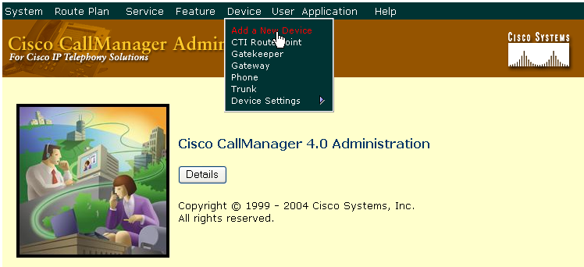
- From the Device type dropdown menu, select Gateway. Click Next. The following screen appears.
Figure 10. Navigating to the Gateway Management Page in ccmadmin
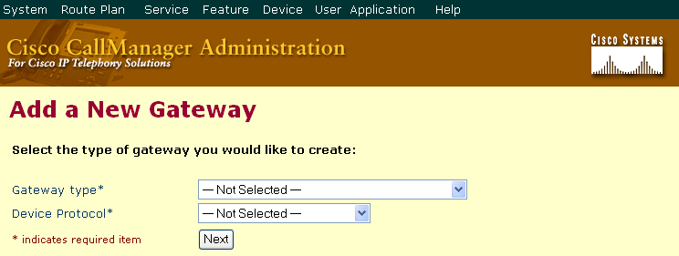
- Scroll down the Gateway type dropdown menu and select H.323 Gateway. The second field should automatically select H.225 as the Device Protocol.
Figure 11. Adding a New Gateway
- Click Next.
- In the Device name field, enter the IP address of the MCE Server.
- In the Description field, enter the text Metreos H.323 gateway, as shown in the following figure.
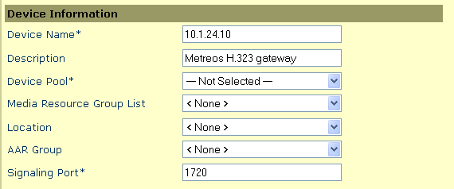
- Under Call Routing, select a Calling Search Space (CSS) that will give the ActiveRelay users an appropriate level of access, as shown in the following figure. The CSS you specify for this gateway will determine the set of phone numbers users can configure as Find Me numbers.
Figure 12. Entering Device Information
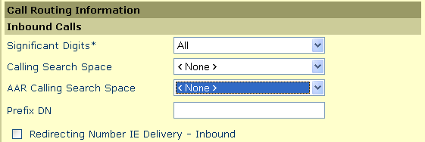
- Click the Insert button.
Figure 13. Call Routing Information
- After a few seconds, CallManager will notify you to reset the gateway device. Click Reset.
  - Adding ActiveRelay to the IP phone service
Complete the following steps to add ActiveRelay to the IP phone service.
Procedure
- Go to https://<servername or IPaddress>/ccmadmin.
- Select Feature→Cisco IP Phone Services.
- Click the Add a New IP Phone Service link in the upper right corner of the window. The following screen appears.
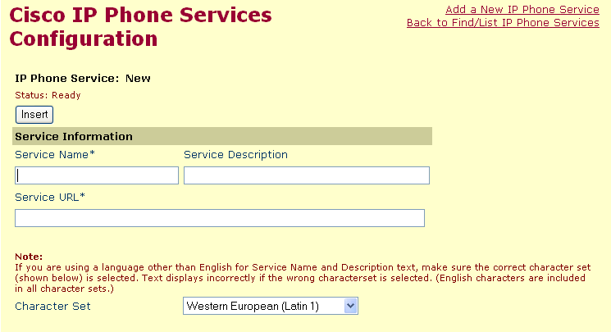
- Enter ActiveRelay in the Service Name field.
Figure 14. Adding ActiveRelay to the IP Phone Service
- In the Server Description field, enter any descriptive text.
- In the Service URL field, specify the following:
http://<MCE_IPAddress>:8000/ActiveRelay?device=#DEVICENAME#
Where <MCE_IPAddress> is the IP address of the MCE server.
For example:
http://10.1.14.101:8000/ActiveRelay?device=#DEVICENAME#
An example screen is shown on the next page.
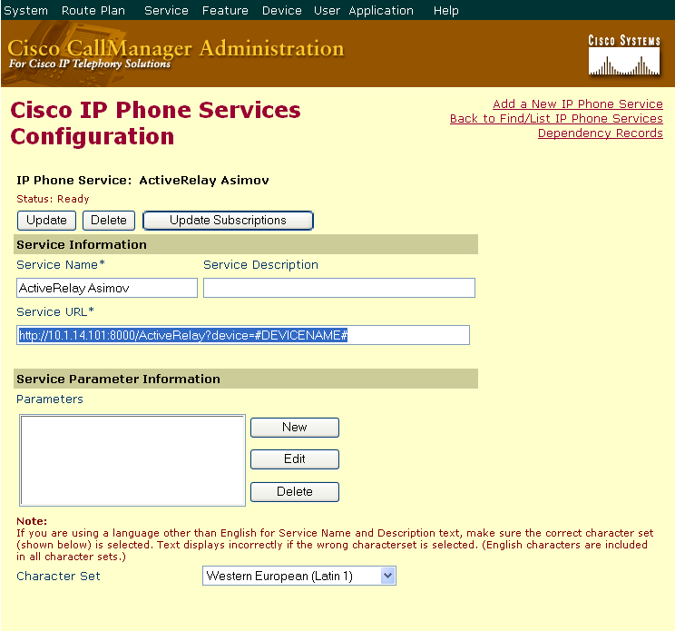
- Click Insert to complete adding IP phone service to ActiveRelay.
Figure 15. Specifying a Service Name and Service URL for ActiveRelay
- Step 3. Install the ActiveRelay Application
Complete the following steps to install the ActiveRelay application.
Procedure
- Go to https://<servername or IPaddress>/ccmadmin
- Under Components, select Applications.
- Under Install an Application, click the Browse button as shown.
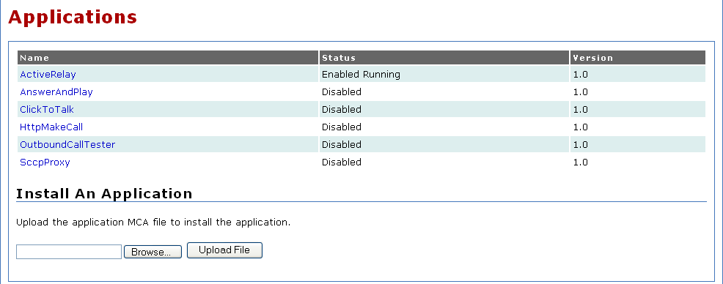
- Browse to the ActiveRelay.mca file from the Metreos directory
Figure 16. Installing the ActiveRelay Application
- Select the ActiveRelay.mca file.
- Click Open.
- Click the Upload File button.
- Step 4. Configure the ActiveRelay Application
When an application is first installed, all configuration items specific to the application are set to default values. One can change the default values at any time by following the steps in this section. All partitions will take the current default values, unless the configuration item was modified on the partition-level.
To change the default values for ActiveRelay configuration items, complete the following steps to modify the ActiveRelay application default configuration.
Procedure
- Go to http://<servername or IPaddress>/mceadmin.
- Select Applications.
- Select ActiveRelay, and proceed to the Default partition configuration page. The following screen appears.
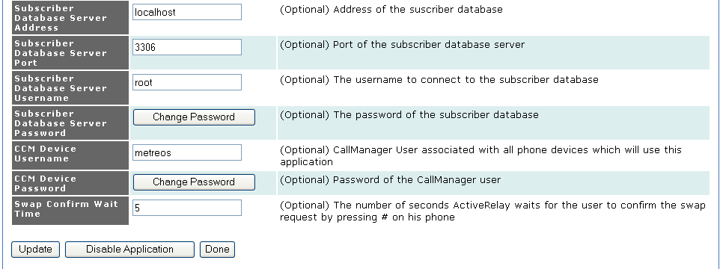
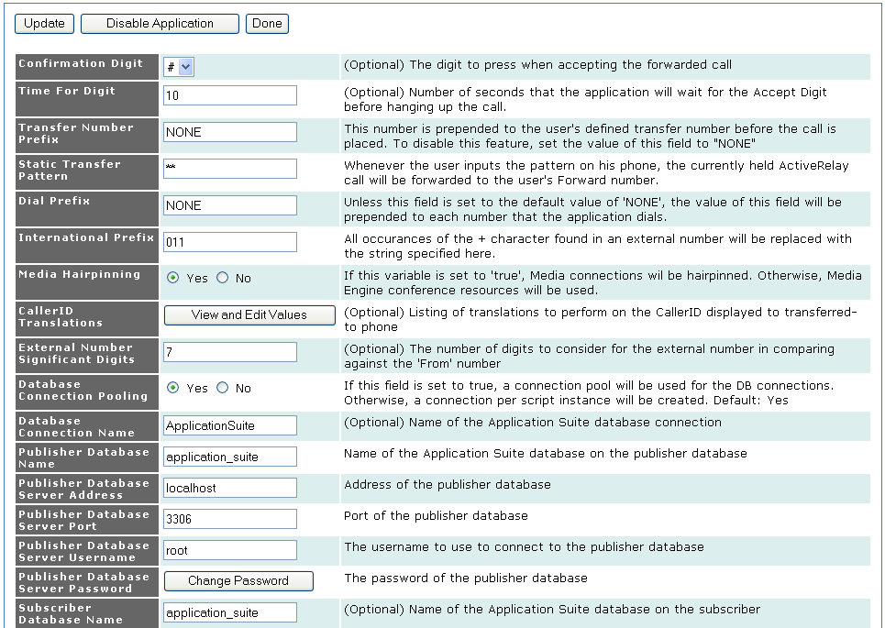
- Enter information into the fields shown above. These fields are described in the next table.
Figure 17. Configuring ActiveRelay in mceadmin
- Ensure that Call Route Group is set to an H.323 gateway.
- Click the Update Configuration button, then click Done.
Field | Description
Enabled | Indicates whether the partition is active.
Call Route Group | Call route group should be an H.323 group to preserve caller ID.
Media Resource Group | The group of media servers that will be used by this partition.
Preferred Codec | Preferred media resource codec.
Confirmation Digit | Key the user presses to accept the call on a Find Me number.
Dial Prefix | If present, ActiveRelay will append the digit(s) to all Find Me numbers when dialing. Set to NONE if no prepend digit is desired.
Media Hairpinning | Select a radio button to enable or disable hairpinning of connections in lieu of two-party conferences. Select Yes to enable hairpinning. Specify No to instead use media firmware conference resources. Hairpinning should always be enabled under normal circumstances.
CallerID Translations | Listing of translations to perform on the Caller ID displayed to the transferred-to phone. Click the View and Edit Values button to change or view caller ID translations.
External Number Significant Digits | When determining if a Find Me number matches the number dialing the user (and therefore should be ignored), ActiveRelay will use this value when comparing the two numbers. Specifically, this value determines the number of digits, starting from the right of the number, which will be used for comparison.
Database Connection Pooling | Select a radio button to enable or disable pooling of database connections. If set to No, a database connection will be created for each ActiveRelay application script instance. Pooling should always be enabled under normal circumstances.
Database Connection Name | Name of the database connection. The default should always be used under normal circumstances.
Publisher Database Name | Name of the application suite database on the publisher server. The default should always be used under normal circumstances.
Publisher Database Server Address | Address of the publisher database application server.
Publisher Database Server Port | Publisher database port number. The default should always be used under normal circumstances.
Publisher Database Server Username | Username associated with the Metreos Application Suite account that is used to connect to the publisher database. This account was specified when the publisher MCE was configured as a publisher. If a publisher/subscriber configuration is not used, the default value of ‘root’ should be used.
Publisher Database Server Password | Click the Database Password button to change the password used to connect to the publisher database. You will be prompted to enter your current password, the new password, and then to verify the new password. After entering the new password, click the Update button. This account password was specified when the publisher MCE was configured as a publisher. If a publisher/subscriber configuration is not used, the default value of ‘metreos’ should be used.
Subscriber Database Name | Name of subscriber database. The default should always be used under normal circumstances.
Subscriber Database Server Address | Address of the subscriber database server when the MCE server is being figured as a subscriber. The default should always be used under normal circumstances.
Subscriber Database Server Port | Port number of the subscriber database server. The default should always be used under normal circumstances.
Subscriber Server Username | Username of the subscriber database server. The default should always be used under normal circumstances.
Subscriber Database Server Password | Password of the subscriber database server. The default should always be used under normal circumstances.
CCM Device Username | Not used.
CCM Device Password | Not used.
Swap Confirm Wait Time | Optional number of seconds ActiveRelay waits for the user to confirm the swap request by pressing # on their phone.
Table 1. ActiveRelay Parameters
- Step 5. Edit the Default Partition
Complete the following steps to edit the default partition.
Procedure
- Go to http://<servername or IPaddress>/mceadmin.
- Under Components, select Applications.
- Select the ActiveRelay application and then proceed to Edit the Default Partition. The following screen appears.
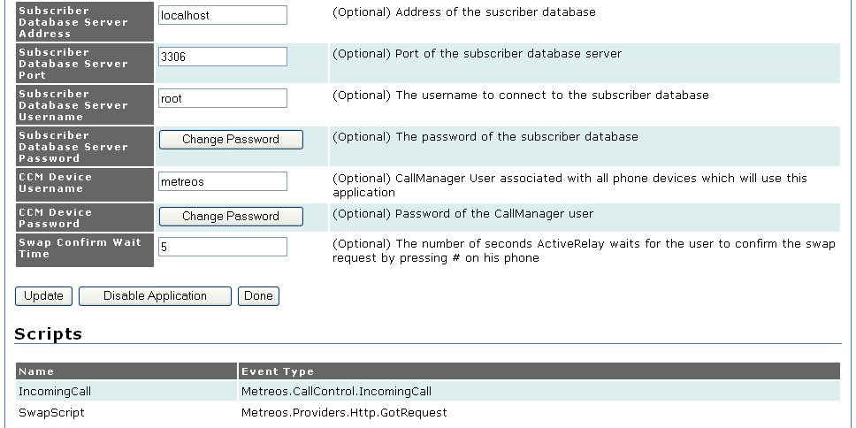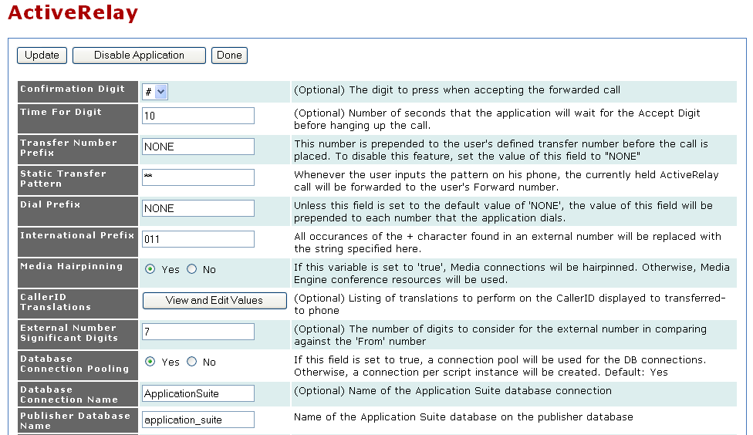
- Modify the ActiveRelay application configuration to meet your specific site requirements. For information on configuration parameters, refer to Table 1 on page 12
Figure 18: Editing the Default Partition
- For Call Route Group, ensure that an H.323 call route group is chosen. While other protocols will succeed in calling Find Me numbers, H.323 is the only outbound protocol which allows the MCE to modify Caller ID—a feature most consider critical for ActiveRelay.
- Step 6. Edit the Trigger Parameter of the ActiveRelay Partition
The MCE matches incoming call control events with its list of trigger parameters to determine when to launch an instance of the ActiveRelay application. Complete the following steps to define the trigger parameter for an ActiveRelay partition.
Procedure
- Go to http://<servername or IPaddress>/mceadmin.
- Select Applications.
- Select the ActiveRelay application, and then proceed to Edit the Default partition. The following screen appears.
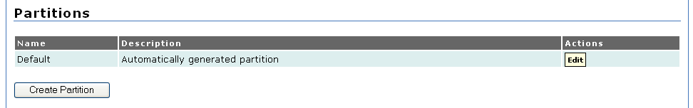
- Under Scripts, click the Edit Trigger Parameter button for the IncomingCall script as shown following.
Figure 21: Editing the Default Partition
- Enter a trigger value for the to parameter. This should correspond to the value of the line number shared between a user and an MCE-hosted SCCP device.
- Click the Add Value button as shown in the following figure.
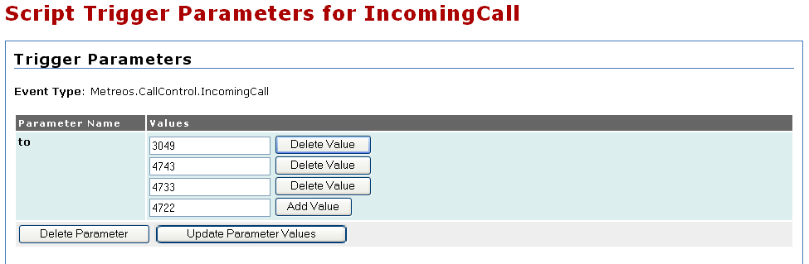
- Click the Update Parameter Values button. A message appears indicating that the parameter value has been updated as shown in the following screen.
Figure 22. Editing the Default Parameter for the IncomingCall Script
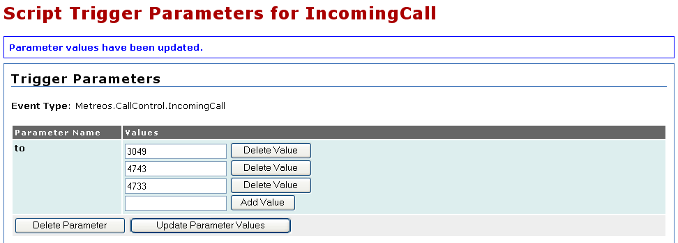
- Step 7. Set Up ActiveRelay Users
Figure 23. Trigger Parameters Value Updated
Complete the following steps to create a user, associate the user’s IP phone device with the new account, and to create a shared line configuration between new ActiveRelay user’s IP phones and an SCCP device pool phone.
Procedure
- Go to http://<servername or IPaddress>/appsuiteadmin.
- Select Account Management.
- Click the Create User button. Enter the information for your account on the following screen.
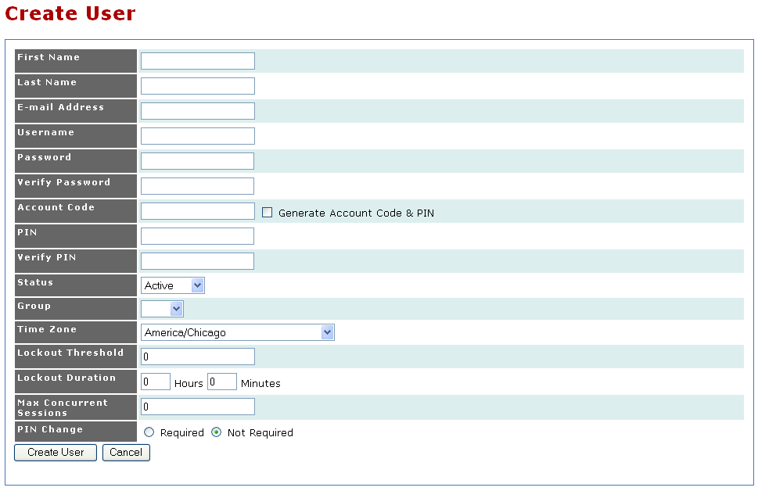
- Click the Create User button.
Figure 19. Adding Users for Your Primary Device in Appsuiteadmin
- Scroll down the screen. Under Devices, click the Add Device button as shown in following screen.
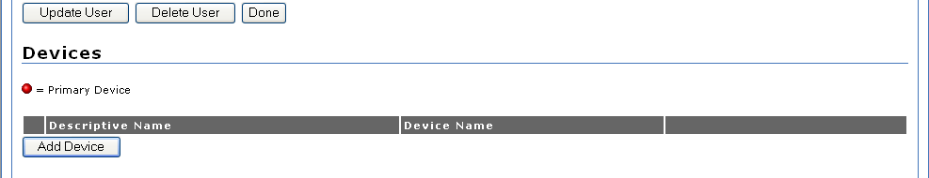
- Enter a name corresponding to the user’s physical IP phone in the following format:
Figure 20. Adding a Device
SEP+MACaddress
- Click the Create Device button to add the device.
- After creating the device, add a line number to the device for each actual line number on the user’s physical IP phone.
- At this time the account is ready. If you so choose, you can configure the Find Me numbers for the account. The user can just as easily now log into appsuiteadmin, and configure their Find Me numbers themselves.
- Step 8: Create a Shared Line Configuration
In this step, you will create a shared line configuration between the user’s IP phone and the MCE-hosted SCCP device.
Procedure
- Determine the enabled user’s line number and partition.
- Go to http://<servername or IPaddress>/ccmadmin to create an MCE-hosted SCCP device that will be used to create a shared line configuration with the user’s IP phone. This device will have originated from the Adding a CallManager telephony server.
- In the MCE-hosted SCCP Device Configuration page, edit the one line number on the SCCP device to match the line number and partition of the user’s IP phone. Once you’ve entered those two values, ccmadmin should show the words Shared Line in red next to the line number field.
- Select the Update button on the MCCE-hosted SCCP device.
- Click the Reset button.
- Step 9: Set Up Other Partitions
Whenever an application such as ActiveRelay is installed, the Default partition is created automatically and initialized with the default configuration parameters defined in the application installer file.
However, any number of partitions can be created for a given application. While there are a number of possible considerations which would cause an administrator to create additional partitions, there are two common reasons: to cause a single application to leverage specific, unique media resources and/or telephony resources based on certain triggering circumstances.
Each partition is associated with a specific Call Route Group and Media Resource Group. Also, any configuration items unique to an application, such as the Confirmation Digit for ActiveRelay, can be modified on a per-partition basis.
With the ability to configure unique Call Route Groups and Media Resource Groups, it is possible to define exactly which media servers are used by specific application partitions, and also define for each partition which CallManager cluster is used when making calls.
Once you have a partition defined, it is then the final responsibility of the administrator to define under which conditions does each partition of ActiveRelay initiate, or trigger.
The following steps should be taken whenever a new partition is determined needed.
Procedure
- Go to http://<servername or IPaddress>/mceadmin.
- Under Components, select Applications.
- Select the ActiveRelay application.
- Under Partitions, Select Create Partition.
- Name and enable the new partition.
- Choose a Call Route Group appropriate for this partition. Call Route Group is used by ActiveRelay when making calls only; determining how inbound calls are treated is administered via a combination of CallManager configuration and triggering parameters on the partition.
- Choose a Media Resource Group appropriate for this partition. When ActiveRelay uses media, mostly for playing the initial confirmation prompt as well as conferencing the two call legs, this group determines which Metreos Media Servers are used.
- Modify any ActiveRelay-specific configuration items as needed.
- Select Create Partition.
- Under Scripts, IncomingCall, select Edit Trigger Parameters.
- For each shared line configured user that should be placed in this group, add a new value which will filter for the to trigger parameter.
- Appendix A: Troubleshooting Symptoms

This appendix is organized by symptoms, and the possible reasons for that symptom.
Symptom | Potential Causes
Dialing DID results in fast busy | R001  R002  R003  R005  R006 | CallManager is not configured to route calls to the Metreos ActiveRelay Route List.  All MCE servers are no longer in service.  There are no available voice channels on the PSTN gateway.  The firewall is blocking H.323 connections on port 1720 from the MCE to CallManager.  The IP addresses of the MCE gateways are not correctly configured in CallManager.
Dialing DID rings, no Find Me numbers ring | R003  R007  R008  R011  R016 | There are no available voice channels on the PSTN gateway.  The MCE that took the call encountered an error starting ActiveRelay.  The configured Call Route Group of the relevant Active Relay partition is not configured correctly.  No media servers are configured on the MCE currently processing the call.  CallManager is not configured to route the number entered as a Find Me number.
Attempt to answer ringing Find Me number results in immediate hang-up | R009  R010 | There are no available RTP media server connections.  There are no available enhanced RTP media server connections.
Attempt to answer ringing Find Me number results in delayed hang-up | R012  R013 | The firewall is blocking the H.245 port range for TCP connections from the MCE to CallManager.  The firewall is blocking the H.245 port range for TCP connections from CallManager to the MCE.
Dialing DID results in significant delay before ringing is heard by dialer | R014  R017 | One or more of the MCE servers are no longer in service.  Multiple route patterns of varying length match the dialed number
Voicemails are left on an ActiveRelay user’s personal device | R015 | Voice Mail Box on the user account is configured to Find Me number.
No Corporate voicemail prompt is reached | R015 | Voice Mail Box on the user account is not configured correctly.
  - R001 CallManager is not configured to route calls to the Metreos ActiveRelay route list
An inbound call from the PSTN H.323 gateway to CallManager will then be routed using CallManager dialing rules. You must have a route pattern in place to route this call to the MCE ActiveRelay Route List.
You will need to be familiar with Cisco dialing rules and/or have access to the Cisco Dialed Number Analyzer utility to follow the procedure below.
Troubleshoot
The partition of the route pattern should be accessible by the CSS of the PSTN gateway servicing the call. This determination can be made either by an administrator familiar with Cisco CallManager dialing rules, and/or by use of the Cisco Dialed Number Analyzer utility.
Resolve
Configure the partition of the route pattern in question appropriately such that the calling search space of the PSTN gateway can route to it.
  - R002 All MCE servers are no longer in service
If all MCE servers were to become unavailable, the ActiveRelay application would also become unavailable.
Troubleshoot
Ideally from the same network on which resides CallManager, attempt to access the MCE administrative web console at http://<MCE servername or IPaddress>/mceadmin. If it is functional, first check the status of the two services, Metreos Application Server and H.323 Stack, found at mceadmin > Service Control. Each of the two services should show a status of Running.
If the services are running as expected, check the logs of these two services for errors, found at mceadmin > Server Logs > H323 and mceadmin > Server Logs > AppServer.
Resolve
If either service is not running, start the service.
If logs exhibit errors for the majority of calls attempted, restart both the H.323 Stack service and the Metreos Application Server service.
  - R003 There are no available voice channels on the PSTN gateway
Calls coming in and going out of the PSTN will use one voice channel per call. If all voice channels are utilized, it is possible that either the inbound or outbound call will fail at the PSTN gateway.
Troubleshoot
Check logs for the PSTN gateway.
Resolve
Increase the number of voice channels available.
Restrict the number of Find Me numbers a user can configure. During the interval that ActiveRelay is trying to find a user, a voice channel is used for each Find Me number configured for the user. Once the user answers the call, however, ActiveRelay will only use one voice channel for the remainder of the call (assuming the call is PSTN-bound).
  - R005 The firewall is blocking H.323 connections on port 1720 from the MCE to CallManager
The H.323 protocol typically connects on port 1720 when attempting to signal a call. A firewall could intercept a request originating from the CallManager destined for the MCE.
Troubleshoot
Check firewall logs for relevant blocked connections.
If possible, attempt to telnet to port 1720 on each MCE from CallManager to verify that the Metreos H.323 stack is accessible.
Resolve
Modify the firewall configuration to allow H.323 connections. For maximum security, ideally the firewall is aware of H.323 and will open H.225 signaling as well as RTP holes as necessary based on signaling.
  - R006 The IP addresses of the MCE gateways are not configured correctly in the CallManager
Each MCE server is configured as an H.323 gateway in the CallManager. If the IP address of any MCE changes after the ActiveRelay application is initially installed, you must update the configuration of the CallManager as well.
Troubleshoot
Manually verify that the IP address of each MCE gateway as configured in CallManager is synchronized.
Resolve
Dialing DID does not result in fast busy.
  - R007 The MCE that took the call encountered an error initiating ActiveRelay
A generic failure such as this within ActiveRelay should rarely occur. A possible cause would be a spike in processor usage due to abnormal call volume.
Troubleshoot
Accessing the AppServer logs found at mceadmin > Server Logs > AppServer will likely provide the information to locate any specific error.
Resolve
If the ActiveRelay application were to continue to exhibit this behavior, the solution may be to add additional MCE servers to the deployment, in order to reduce the load across all servers.
  - R008 The configured Call Route Group of the relevant Active Relay partition is not configured correctly
The Metreos Application Server supports sending H.323, CTI, and SCCP calls to any number of CallManagers. This specific protocol and telephony endpoints used in delivering calls are decided by the configured Call Route Group of the application partition handling the call.
Troubleshoot
Access the configuration for the Call Route Group of the partition of ActiveRelay servicing the problematic user or set of users, at mceadmin > Applications > ActiveRelay > Edit Partition > Call Route Group. Once the Call Route Group is known, it can be referenced and verified in mceadmin > Telephony Servers > Call Route Groups > [Choose Group] > Edit Group.
Resolve
Create a new Call Route Group, or modify an existing Call Route Group, with members representing the correct endpoints that process calls for ActiveRelay users. Associate this Call Route Group with the relevant ActiveRelay partition.
  - R009 There are no available RTP media server connections
A finite number of media ports are available to the Metreos Application Server. Once all are in use, successive ActiveRelay calls cannot be processed until ports become available again.
Troubleshoot
An alarm is raised by the Metreos Application Server when RTP ports are no longer available, providing to the administrator immediate notification of RTP media port exhaustion.
Resolve
Add additional RTP media ports and/or Metreos Media Server hardware.
  - R010 There are no available enhanced RTP media server connections
A limited number of enhanced RTP media ports are available to the Metreos Application Server.
Troubleshoot
An alarm is raised by the Metreos Application Server when enhanced RTP ports are no longer available, providing to the administrator immediate notification of enhanced RTP media port exhaustion.
Resolve
Add additional enhanced RTP media ports and/or Metreos Media Server hardware.
  - R011 No media servers are configured on the MCE currently processing the call
Each Metreos Application Server will be configured to control some number of Metreos Media Servers, which are then further organized into Media Resource Groups. Every partition of the ActiveRelay application must have a media resource group associated with it, and that group must have media server nodes in it.
Troubleshoot
Access the configuration for the Media Resource Group of the partition of ActiveRelay servicing the problematic user or set of users, at mceadmin > Applications > ActiveRelay > Edit Partition > Media Resource Group. Once the Media Resource Group is known, it can be referenced and verified in mceadmin > Media Servers > Media Resource Groups > [Choose Group] > Edit Group.
Resolve
Create a new Media Resource Group, or modify an existing Media Resource Group, with members representing the correct media servers to provide RTP ports. Associate this Media Resource Group with the relevant ActiveRelay partition.
  - R012 The firewall is blocking the H.245 port range for TCP connections from the MCE to CallManager
The Metreos Application Server will signal an H.323 call to CallManager for every configured Find Me number when an ActiveRelay user is called. If the H.245 port range is blocked in a firewall, calls to Find Me numbers will ring but they cannot be answered. In addition, CallManager will automatically retry the call, which will fail similarly.
Troubleshoot
The re-ringing of Find Me numbers is a distinct characteristic of H.245 signaling being blocked by a firewall. To verify this issue, check the firewall logs for blocked connections.
Resolve
Configure the firewall to allow the MCE to originate H.225 connections to CallManager
  - R013 The firewall is blocking the H.245 port range for TCP connections from CallManager to the MCE
CallManager will signal a single H.323 call to the MCE whenever an ActiveRelay user’s DID is called. If the H.245 port range is blocked in a firewall, calls to the Find Me numbers will ring, but they can not be answered. In addition, CallManager will automatically retry the call, which will fail similarly.
Troubleshoot
The re-ringing of Find Me numbers is a distinct characteristic of H.245 signaling being blocked by a firewall. To verify this issue, check the firewall logs to check for blocked connections.
Resolve
Configure the firewall to allow CallManager to originate H.245 connections to the MCE. This range is by default 10,000 to 11,000. Note that the H.323 provider on the Metreos Application Server can be configured to use a specific range. This configuration can be found at mceadmin > Providers > H.323 Provider.
  - R014 One or more of the MCE servers are no longer in service
If one or more of the MCE servers is down, it will take longer for a call to go through to an ActiveRelay-enabled user. CallManager will try every MCE in the configured ActiveRelay Route List until it successfully makes a TCP connection.
Troubleshoot
Attempt to access (ideally from the same network on which CallManager is resident) the MCE administrative web console at http://<MCE servername or IPaddress>/mceadmin. If it is functional, first check the status of the two services, Metreos Application Server and H.323 Stack, found at mceadmin > Service Control. Each of these services should have a status of Running.
If the services are running, check the service logs for errors, found at mceadmin > Server Logs > H323 and mceadmin > Server Logs > AppServer.
Resolve
If either of the two services is not running, start the service.
If the logs show errors for the majority of calls attempted, restart both the H.323 Stack service and the Metreos Application Server service.
The CallManager H.323 Service Parameter, H225 TCP Timer, should be as short as possible, since a call first routed to a down gateway will incur a delay equal to the amount of time configured for the H225 TCP Timer.
  - R015 Voice Mail Box on the user account is not configured correctly
One Find Me number can be configured to not require confirmation on pickup. This allows a single voicemail system to own the ActiveRelay call if it picks up on such a Find Me number. The dropdown in the user account profile named Voice Mail Box delineates this Find Me number.
Troubleshoot
Access the user’s profile page found at appsuiteadmin > Account Management > Edit > Find Me Numbers section. Ensure that the Find Me number which should answer voice mail is designated as such in the Voice Mail Box dropdown.
Resolve
Update the Voice Mail Box to designate the correct Find Me number.
  - R016 CallManager is not configured to route the number entered as a Find Me number
The MCE originates one call per Find Me number when a user is called. Therefore, the CSS of the H.323 gateway(s) that represent the MCE must be such that it can route Find Me numbers to the PSTN and elsewhere, typically via route patterns.
Troubleshoot
The partition of the route pattern should be accessible by the CSS of the MCE H.323 gateway servicing the call. This determination can be made either by an administrator familiar with Cisco CallManager dialing rules, or by using the Cisco Dialed Number Analyzer utility.
Resolve
Configure the partition of the route pattern in question appropriately, such that the calling search space of the MCE H.323 gateway can route to it. The MCE H.323 gateway configuration should not be altered, and its configured CSS should not be changed. The CSS itself may however be edited, if necessary, to access route patterns in partitions not currently configured as a part of the CSS.
  - R017 Multiple route patterns of varying length match the dialed number
Multiple route patterns in CallManager match the dialed number, some of which are comprised of more digits and therefore CallManager waits for the configured inter-digit delay timeout period before sending the call
Troubleshoot
To determine if inter-digit delay is the cause of a delay before the inbound call begins to ring, dial the problematic number with a SCCP phone. If the call rings after a long delay, hang up the call, and use the Redial softkey to call again. Inter digit delay is the problem if the call connects immediately.
Resolve
Verify that there are not route patterns, translation patterns, or directory numbers with leading digits that match the number being dialed, and are longer.

